SQL – Assignment 3 - Ass1_Opt2+_EmpMgnt
Question:
Login SQL Server and create database name EMS, run below script to generate tables:
...
Write SQL statements for following activities & print out respectively the screenshots to show test data (the table data that you create to test each query) & query results:
- Add at least 8 records into each created tables.
Answer:
--Department
INSERT INTO dbo.Department(DeptName, Note) VALUES('Customer Service', 'Support customers')
INSERT INTO dbo.Department(DeptName, Note) VALUES('Human Resources ', 'hiring, benefits,...')
INSERT INTO dbo.Department(DeptName, Note) VALUES('Marketing', 'PR')
INSERT INTO dbo.Department(DeptName, Note) VALUES('Sales', 'Manage sale')
INSERT INTO dbo.Department(DeptName, Note) VALUES('Research & Development', 'Research & Development')
INSERT INTO dbo.Department(DeptName, Note) VALUES('Quality Esurance', 'Ensure quality of products')
INSERT INTO dbo.Department(DeptName, Note) VALUES('Finance', 'Manage company finances')
INSERT INTO dbo.Department(DeptName, Note) VALUES('IT', 'Support about IT')

--Employee
INSERT INTO dbo.Employee VALUES (1,'Mike Ambinder', '8/21/1984', 1, '', '2/10/2008', 1500, 1, 'Note1', 4, '1@gmail.com')
INSERT INTO dbo.Employee VALUES (2,'Jeep Barnett', '7/15/1982', 2, '1', '4/24/2010', 1000, 0, 'Note2', 1, '2@gmail.com')
INSERT INTO dbo.Employee VALUES (3,'Kaci Aitchison', '2/21/1987', 3, '1', '1/5/2015', 1750, 2, 'Note3', 2, '3@gmail.com')
INSERT INTO dbo.Employee VALUES (4,'Andrea Wendel', '7/15/1988', 5, '1', '4/6/2012', 800, 2, 'Note4', 7, '4@gmail.com')
INSERT INTO dbo.Employee VALUES (5,'Greg Coomer', '3/21/1978', 2, '2', '7/1/2015', 900, 1, 'Note5', 6, '5@gmail.com')
INSERT INTO dbo.Employee VALUES (6,'Mike Dunkle', '1/25/1982', 6, '2', '3/9/2008', 1500, 0, 'Note6', 6, '6@gmail.com')
INSERT INTO dbo.Employee VALUES (7,'Emilia Clarke', '2/21/1990', 3, '3', '2/4/2015', 1200, 0, 'Note7', 5, '7@gmail.com')
INSERT INTO dbo.Employee VALUES (8,'Dave Feise', '4/15/1984', 4, '1', '2/6/2008', 1300, 1, 'Note8', 3, '8@gmail.com')

--Skill
INSERT INTO dbo.Skill(SkillName, Note) VALUES('C++', 'Note 1')
INSERT INTO dbo.Skill(SkillName, Note) VALUES('.NET', 'Note 2')
INSERT INTO dbo.Skill(SkillName, Note) VALUES('Java', 'Note 3')
INSERT INTO dbo.Skill(SkillName, Note) VALUES('Python', 'Note 4')
INSERT INTO dbo.Skill(SkillName, Note) VALUES('Ruby', 'Note 5')
INSERT INTO dbo.Skill(SkillName, Note) VALUES('Design', 'Note 6')
INSERT INTO dbo.Skill(SkillName, Note) VALUES('PR', 'Note 7')
INSERT INTO dbo.Skill(SkillName, Note) VALUES('Negotiation', 'Note 8')

--Emp_Skill
INSERT INTO dbo.Emp_Skill VALUES (1, 1, 3, '2/6/2008','Description 1')
INSERT INTO dbo.Emp_Skill VALUES (2, 1, 2, '2/6/2008', NULL)
INSERT INTO dbo.Emp_Skill VALUES (3, 1, 4, '2/6/2008', NULL)
INSERT INTO dbo.Emp_Skill VALUES (2, 2, 3, '2/6/2008','Description 2')
INSERT INTO dbo.Emp_Skill VALUES (3, 3, 3, '2/6/2008','Description 3')
INSERT INTO dbo.Emp_Skill VALUES (5, 4, 3, '2/6/2008','Description 4')
INSERT INTO dbo.Emp_Skill VALUES (1, 5, 3, '2/6/2008','Description 5')
INSERT INTO dbo.Emp_Skill VALUES (7, 5, 3, '2/6/2008','Description 6')
INSERT INTO dbo.Emp_Skill VALUES (6, 6, 3, '2/6/2008','Description 7')
INSERT INTO dbo.Emp_Skill VALUES (7, 7, 3, '2/6/2008','Description 8')
INSERT INTO dbo.Emp_Skill VALUES (4, 8, 3, '2/6/2008','Description 9')

Result:
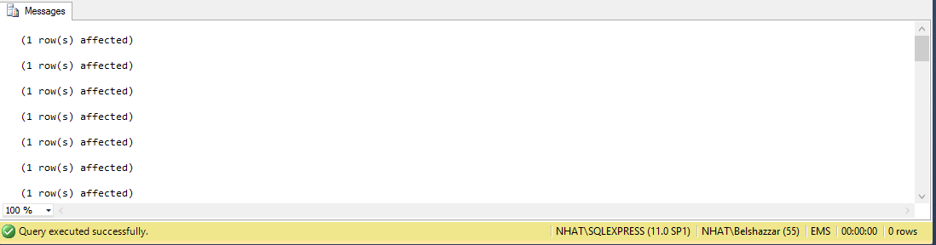

- Test data for question b, c, d, e, f, g, h:
- Department
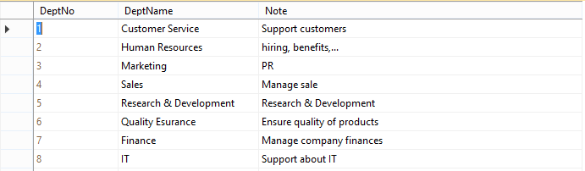

- Employee
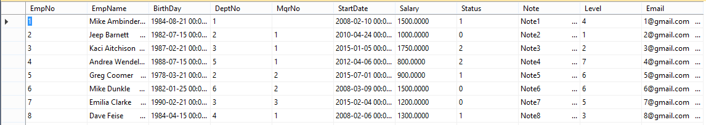

- Skill
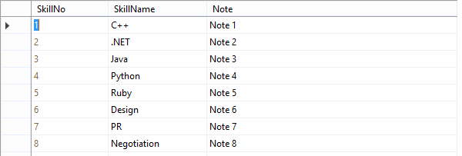

- Emp_Skill
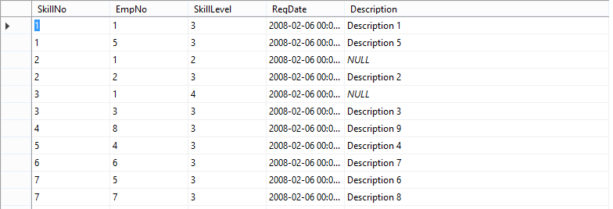
- Specify name, email and department name of the employees that have been working at least six months.
Answer:
SELECT [EmpName], [Email], [DeptName]
FROM dbo.Employee, dbo.Department
WHERE dbo.Employee.DeptNo = dbo.Department.DeptNo
AND DATEDIFF(MONTH, [StartDate], GETDATE()) >= 6

Result:
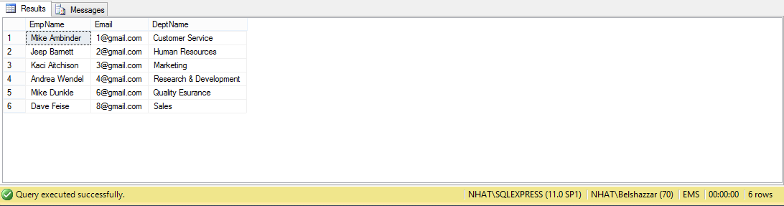

- Specify the names of the employees whore have either ‘C++’ or ‘.NET’ skills.
Answer:
SELECT DISTINCT [EmpName]
FROM dbo.Employee, dbo.Skill, dbo.Emp_Skill
WHERE dbo.Emp_Skill.EmpNo = dbo.Employee.EmpNo
AND dbo.Emp_Skill.SkillNo = dbo.Skill.SkillNo
AND (dbo.Skill.SkillName = 'C++' OR dbo.Skill.SkillName = '.NET')

Result:
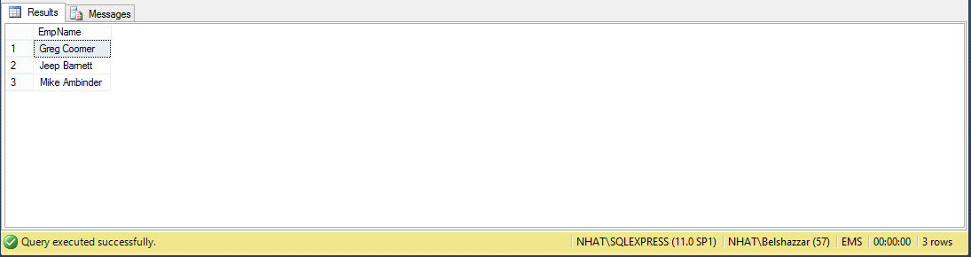

- List all employee names, manager names, manager emails of those employees.
Answer:
SELECT e1.EmpName, ISNULL(e2.EmpName, 'Top manager') AS ManagerName, e2.Email AS ManagerEmail
FROM dbo.Employee e1
LEFT JOIN dbo.Employee e2
ON e1.MgrNo = e2.EmpNo

Result:
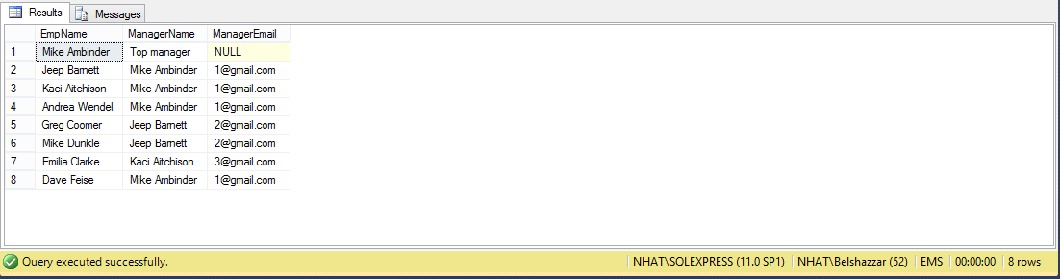

- Specify the departments which have >=2 employees, print out the list of departments’ employees right after each department.
Answer:
SELECT [DeptName], [EmpNo], [EmpName]
FROM dbo.Employee, dbo.Department
WHERE dbo.Employee.DeptNo = dbo.Department.DeptNo
AND dbo.Department.[DeptNo] IN
(
SELECT [DeptNo]
FROM(SELECT [DeptNo], Count(EmpNo) as num
FROM dbo.Employee
GROUP BY [DeptNo]) as MyTable
WHERE num >= 2
)
ORDER BY [DeptName]

Result:
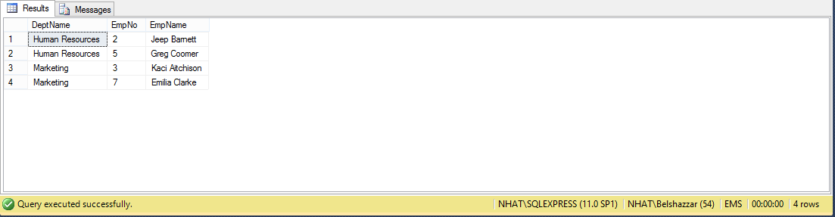

- List all name, email and skill number of the employees and sort ascending order by employee’s name.
Answer:
SELECT [EmpName], [Email], Skill.[SkillNo]
FROM dbo.Employee, dbo.Skill, dbo.Emp_Skill
WHERE dbo.Emp_Skill.EmpNo = dbo.Employee.EmpNo
AND dbo.Emp_Skill.SkillNo = dbo.Skill.SkillNo
Order by [EmpName] ASC

Result:
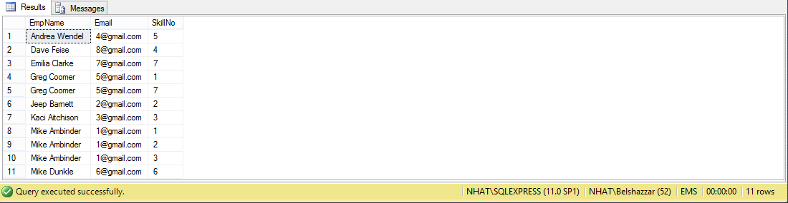

- Use SUB-QUERY technique to list out the different employees (include name, email, birthday) who are working and have multiple skills.
Answer:
SELECT [EmpName], [Email], [BirthDay]
FROM dbo.Employee
WHERE [EmpNo] IN
(
SELECT [EmpNo]
FROM (SELECT [EmpNo], Count(EmpNo) as num
FROM dbo.Emp_Skill
GROUP BY [EmpNo]) as MyTable
WHERE num >= 2
)
AND [Status] = 1

Result:
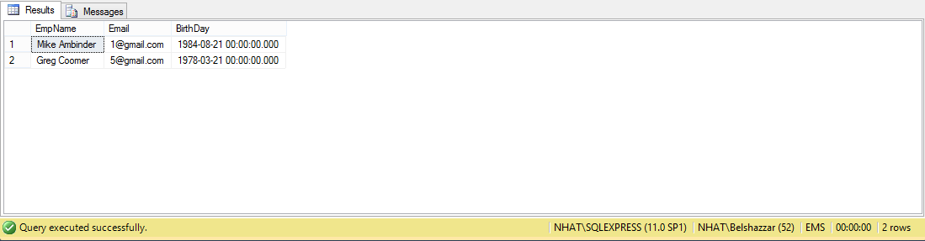

- Create a view to list all employees are working (include: name of employee and skill name, department name).
Answer:
CREATE VIEW CurrentEmployee AS
SELECT [EmpName], [SkillName], [DeptName]
FROM dbo.Department, dbo.Skill, dbo.Employee, dbo.Emp_Skill
WHERE dbo.Emp_Skill.EmpNo = dbo.Employee.EmpNo
AND dbo.Emp_Skill.SkillNo = dbo.Skill.SkillNo
AND dbo.Employee.DeptNo = dbo.Department.DeptNo
AND [Status] = 1

Result:
